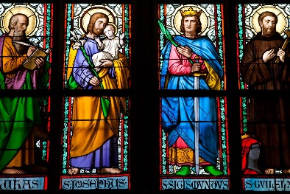
Nativity of Our Lord Parish
Confirmation Saint Name Project

“I have called you by name: you are mine” (Isaiah 43:1).

Choosing a Confirmation name is an important decision. Once decided, a candidate must take the time to carefully research the life of the Saint whose name they have chosen. This research will help focus on the reasons for this choice.
The following information must be included in whichever project option you choose:

Introduction
What is the Saint’s full name? When and where was the Saint born?
What did you learn about the Saint’s family?
Tell the major parts of the story of this Saint’s life.
When and how did this Saint die?
What is the feast day of this Saint? Is there a shrine dedicated to this Saint?
Include a picture of this Saint. Include a prayer for or by this Saint.
List at least one book and at least one website where you researched this information.

Reflection
Which Saint have you chosen? Why have you chosen this Saint’s name?
How is this Saint a good example of being a disciple of Jesus?
Of what or where is this Saint a patron?
Reflect on and tell some things that this Saint did in his or her life that had an impact on you.

Application
Tell some qualities and virtues that your Saint had that you would like to imitate in your own life.
Give specific examples of things you plan to do in your daily life to grow in these virtues and characteristics.

Due Date: On or before 1/8/2024

(over →→→→→

Option 1: Essay
This essay must be typed, double spaced, 12-point font. It should include a cover page with your name, a picture of the Saint, and a prayer for the Saint. It should be no more than two pages, and it should include the responses to all questions detailed on the front page of this paper.

Option 2: Visual Display
You should creatively display all the information detailed on the front page of this paper. Although not in essay form, all questions should be answered, and all material should be covered. You may choose the medium for this display (for example: a brochure or poster display). Please do not use large 3-fold poster display boards. The projects are exhibited in the hallway, and the large 3-fold poster display boards cannot be accommodated.

The following are a few resources to obtain information about Saints: www.catholic.org/saints www.newadvent.org/cathen/ahtm; www.theworkofgod/org.saints www.catholicforum.com/saints

This project should be completed by the due date specified. Projects may be turned in to the Religious Education Office any time prior to the due date, or may be turned into the classroom teacher or PREP Catechist who will forward the project to the PREP office. We will be assessing the project as a measure of preparation prior to Confirmation; however, the teacher or Catechist may use this as an assessment for a grade. Please follow any other directions given by the Catechist or teacher, and please feel free to contact me with any questions.

Pax Christi,
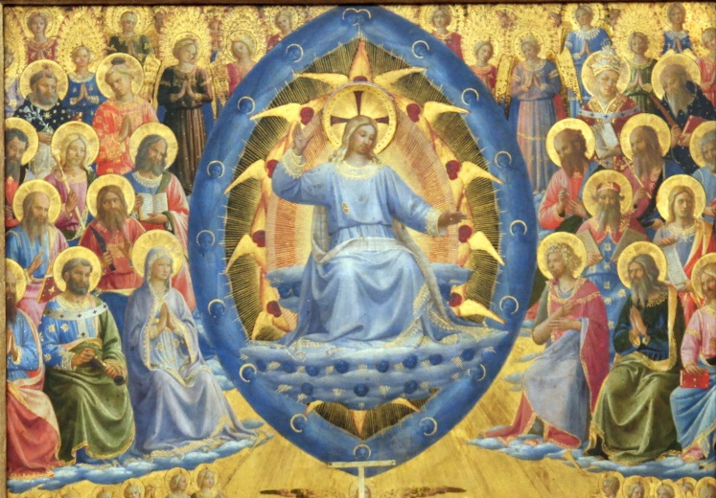

Mr. Kyle Thompson
Director of Religious Education
Nativity of Our Lord
215-672-5316
kthompson@noolp.org

