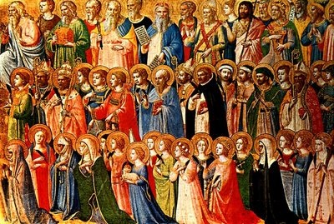

Confirmation Saint Name Project (due 1/8/2024)

Use this checklist to help ensure you have included all information and requirements in your final project:

Full Name of Saint: _____
Date and Place of Birth: _____
Information on Saint’s Family: _____
Major Parts of the Saint’s Life: _____
When the Saint Died: _____
How the Saint Died: _____
Feast Day: _____
Does the Saint have a shrine? _____
Picture of Saint: _____
Prayer for Saint: _____
Title of Book Used as a Resource: _____
Website Used as a Resource: _____
Why have you chosen this Saint? _____
How is this Saint a good example of being a disciple of Jesus? _____
What is this Saint the patron of? _____
Reflect on and tell some things this Saint did in his or her life
that had an impact on you. _____
Tell some qualities and virtues that your Saint had that you
would like to imitate in your own life. _____
Give specific examples of things you plan to do in your
daily life to grow in these virtues and characteristics. _____

